First Christian Church

July 21, 2024 Marshall Missouri 10:00 AM

Minister- Rev. Randal DeMasters

Welcome Songs “A Blessed Seed” FCC Praise Band
( original by Joe Palen)
Call to Worship
Opening Hymn “Open the Eyes of My Heart Lord” Power Point

Open the eyes of my heart, Lord, Open the eyes of my heart
I want to see You, I want to see You
Open the eyes of my heart, Lord, Open the eyes of my heart
I want to see You, I want to see You
To see You high and lifted up, Shinin' in the light of Your glory
Pour out Your power and love, As we sing holy, holy, holy
[REPEAT]
Holy, holy, holy, holy, holy, holy,
holy, holy, holy, I want to see you.
[REPEAT]

Invocation and Lord’s Prayer Our Father who art in heaven, hallowed be thy name. Thy kingdom come, thy will be done, on earth as it is in heaven. Give us this day our daily bread. And forgive us our debts, as we forgive our debtors. Lead us not into temptation, but deliver us from evil. For thine is the kingdom, and the power, and the glory, forever. Amen

Invitation to Communion and Communion Prayer
Holy Communion
The celebration of the Lord’s Supper is the central focus of our faith and worship together.
All who believe in Jesus Christ are invited to partake in the sacraments.

Offering Statement/ Prayer of Dedication
Good News for the Young at Heart

Special Music “Jesus Does” FCC Praise Band

Sermon Rev. Randal DeMasters
Scripture 2 Samuel 7:1-14a, Jeremiah 23:1-6, Ephesians 2:11-22

Invitation
Any person desiring to profess Jesus Christ as Lord and Savior, or to transfer their church membership to this congregation, is now invited forward.

Closing Hymn “Amazing Grace/My Chains Are Gone” Power Point

Amazing grace how sweet the sound, That saved a wretch like me
I once was lost, but now I'm found, Was blind, but now I see

'Twas grace that taught my heart to fear, And grace my fears relieved
How precious did that grace appear, The hour I first believed

My chains are gone, I've been set free, My God, my Savior has ransomed me
And like a flood His mercy reigns, Unending love, Amazing grace
[repeat]
The earth shall soon dissolve like snow, The sun forbear to shine
But God, who called me here below, Will be forever mine, will be forever mine
You are forever mine

Benediction

CHURCH ANNOUNCEMENTS
Please take a moment to think of our members who are unable to attend or have not attended our services lately, and send them a card or note. This week, consider sending your thoughts and prayers to Norman Gibbins. You can mail them directly to the following address:
C/O Westport Assisted Living 904 Apache Drive Marshall, MO 65340

The Ladies Luncheon will meet at Pizza Hut on August 1st at 11:30am. Everyone is invited to attend.

Volunteers are needed for the July-August 8:00 Drive-Up services. There is a sign-up sheet by the East door for those who are willing to help. Everything is set up and ready to go for you each Sunday. Your duties would be to help pass out communion and bulletins, collect
offering and play music.

Shirley Kueker departed this life for her Heavenly Home in the early morning hours of July 10, 2024. Her daughter has asked that memorials in her name be given to First Christian Church.

BIRTHDAYS
07/22 Norman Gibbins

ANNIVERSARIES
07/21 David & Kara Clark 07/23 Vince & Jill Buck 07/26 John & Trish Fletcher

PRAYER LIST
Helen Merchant Alisa Smith Pat Krause Vic Hessel Jo Nell Fizer Beth LaGore Gretchen Edwards Norman Gibbins
Cody Samson Tom McRoberts Madison Palen Betty Jensen
JoDell Alexander

Please take a moment to fill out our Attendance Registration that is located in a blue folder in each pew seat.
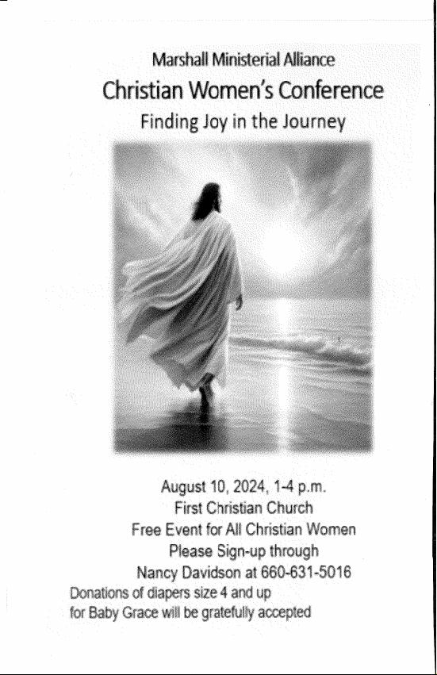

Attendance: July 14, 2024
8:00 Dive-Up: 40
10:00 Worship: 33
Total: 73

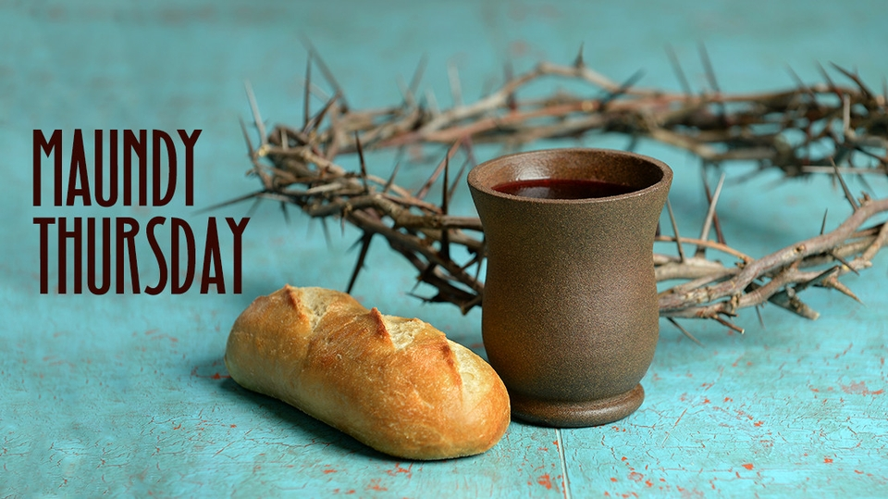

For those who wish
to give offering, an offering
plate/box has been placed on
tables in the Sunroom and entryway into the
Sanctuary. You may also give online via “Givelify”.
Thank you for coming today.

