First Christian Church

June 16, 2024 Marshall Missouri 10:00 AM

Minister- Rev. Randal DeMasters

Welcome Songs “The Lord’s Prayer” FCC Praise Band
Call to Worship
Opening Hymn “I’ll Fly Away” Power Point

Some glad morning when this life is o'er, I'll fly away
To a home on God's celestial shore, I'll fly away

Chorus:
I'll fly away O glory I'll fly away (in the morning)
When I die hallelujah by and by I'll fly away

When the shadows of this life have grown, I'll fly away
Like a bird from prison bars has flown, I'll fly away
[Chorus]
Just a few more weary days and then, I'll fly away
To a land where joys shall never end, I'll fly away
[Chorus]
I'll fly away, I'll fly away, fly away

Invocation and Lord’s Prayer Our Father who art in heaven, hallowed be thy name. Thy kingdom come, thy will be done, on earth as it is in heaven. Give us this day our daily bread. And forgive us our debts, as we forgive our debtors. Lead us not into temptation, but deliver us from evil. For thine is the kingdom, and the power, and the glory, forever. Amen

Invitation to Communion and Communion Prayer
Holy Communion
The celebration of the Lord’s Supper is the central focus of our faith and worship together.
All who believe in Jesus Christ are invited to partake in the sacraments.

Offering Statement/ Prayer of Dedication
Good News for the Young at Heart

Special Music “Daddy’s Hands” FCC Praise Band

Sermon Sharae Kelley
Scripture Psalm 20, 2 Corinthians 5:6-10, 14-17, Mark 4:26=34

Invitation
Any person desiring to profess Jesus Christ as Lord and Savior, or to transfer their church membership to this congregation, is now invited forward.

Closing Hymn “Shout to the Lord” PowerPoint
My Jesus, my Saviour, Lord there is none like You
All of my days I want to praise, The wonders of Your mighty love
My comfort, my shelter, Tower of refuge and strength
Let every breath, all that I am, Never cease to worship You

Shout to the Lord all the Earth, let us sing, Power and majesty, praise to the King
Mountains bow down and the seas will roar At the sound of Your name
I sing for joy at the work of Your hands, Forever I'll love You, forever I'll stand
Nothing compares to the promise I have In You.

[ repeat all]

Nothing compares to the promise I have.
Nothing compares to the promise I have
Nothing compares to the promise I have In You.

Benediction
CHURCH ANNOUNCEMENTS
Please take a moment to think of our members who are unable to attend or have not attended our services lately, and send them a card or note. This week, consider sending your thoughts and prayers to Ruth Marsh. You can mail them directly to the following address:

C/O Big Bend 620 N. Emmerson St Slater, MO 65349

Volunteers are needed for the July-August 8:00 Drive-Up services. There is a sign-up sheet by the East door for those who are willing to help. Everything is set up and ready to go for you each Sunday. Your duties would be to help pass out communion and bulletins, collect offering and play music.

It is our rotation to serve Meals-On-Wheels the week of June 17th. If you are able to help, please notify Ken Bryant, or call the Church office at 660- 886-3338.

If you have an article, or announcement for the July newsletter, please have it submitted by June 18th.


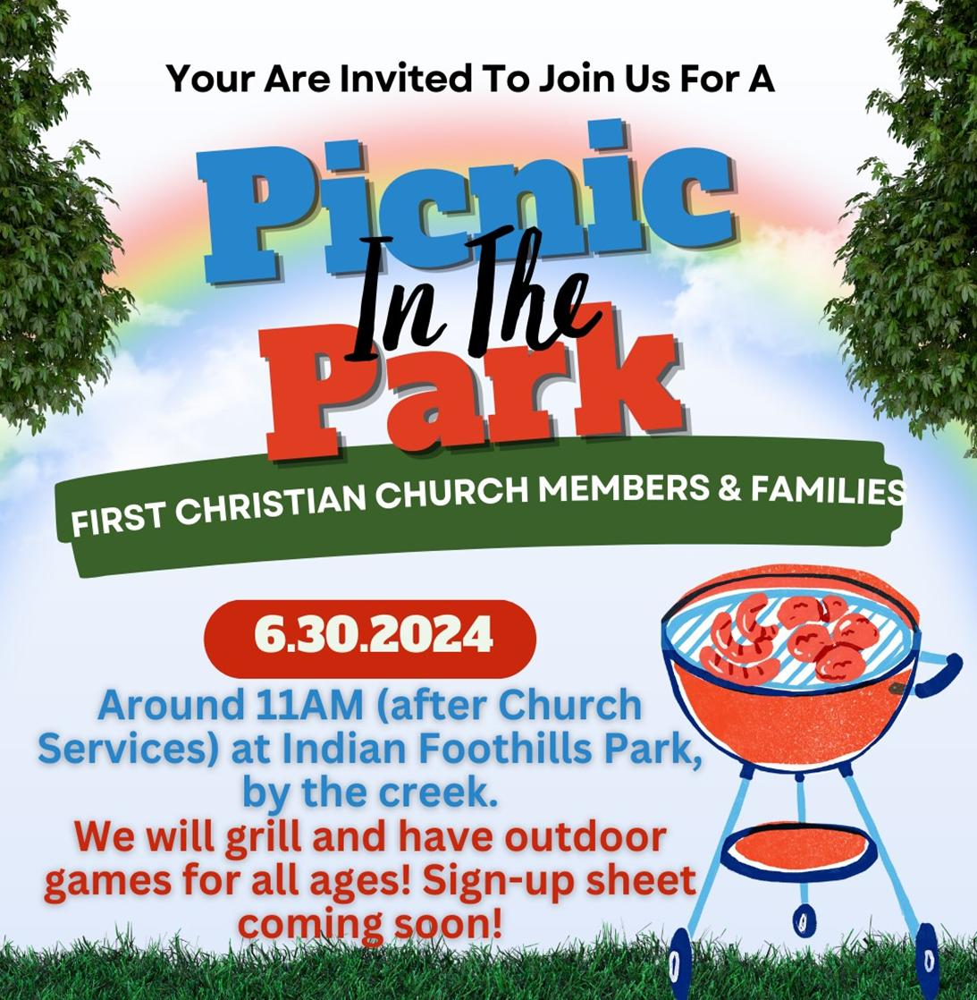
To ensure a good variety of sides and games, a Sign-Up Genius site is available at signupgenius.com.
When prompted, enter kinzi_schultz@hotmail.com

You can also sign up on the poster on the easel at the Church east entrance, or email kenzi_schultz@hotmail.com

BIRTHDAYS
06/16 Jay Yoder 06/18 Avery Schroeder 06/20 Paul Scarff
06/18 John McGraw 06/20 Georganne DeMoss 06/21 Dennis Carter
06/18 Joe Palen 06/20 Tim Hessel

ANNIVERSARIES

PRAYER LIST

Helen Merchant Alisa Smith Shirley Kueker Pat Krause Vic Hessel Jo Nell Fizer Beth LaGore Gretchen Edwards Norman Gibbins Cody Samson Tom McRoberts Madison Palen
JoDell Alexander

Attendance: June 9, 2023 Please take a moment to fill out our Attendance
8:00 Dive-Up: 51 Registration that is located in a blue folder in each pew seat.
10:00 Worship: 29
Total: 80

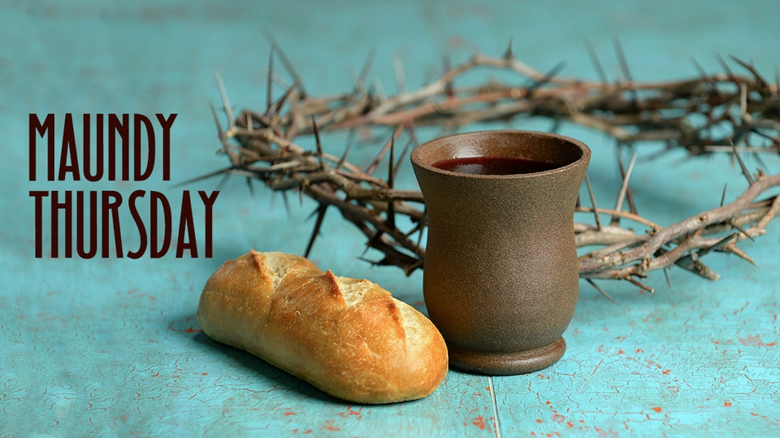

For those who wish to give offering, an offering plate/box has been placed
on tables in the Sunroom and entryway into the Sanctuary. You may also give online via “Givelify”. Thank you for coming today.

